**Sprint 1 - Endurance Design Document**

April 1**,** 2022

**Table of Contents**

**1.** **EXECUTIVE SUMMARY 3**

1.1 Project Overview 3

1.2 Purpose and Scope of this Specification 3

**2.** **PRODUCT/SERVICE DESCRIPTION 3**

2.1 Product Context 3

2.2 User Characteristics 3

2.3 Assumptions 3

2.4 Constraints 3

2.5 Dependencies 4

**3.** **REQUIREMENTS 4**

3.1 Functional Requirements 5

3.2 Security 5

*3.2.1* *Protection 5*

*3.2.2* *Authorization and Authentication 6*

3.3 Portability 6

**4.** **REQUIREMENTS CONFIRMATION/STAKEHOLDER SIGN-OFF 6**

**5.** **SYSTEM DESIGN 6**

5.1 Algorithm 6

5.2 System Flow 6

5.3 Software 6

5.4 Hardware 6

5.5 Test Plan 7

5.6 Task List/Gantt Chart 7

5.7 Staffing Plan 7

# Executive Summary

## ***Project Overview***

This document includes some of the documents, files, and other information required for the endurance-sprint portion (Sprint 1) of the CS104 Robotics Triathlon as outlined in the CS 104-01 Class syllabus for Spring 2022. The robot must complete a rectangle course on the floor of room HH-208. A video will be taken to show the robot completing its task.

## ***Purpose and Scope of this Specification***

**In scope**

* This part includes the testing for Endurance only, this is further explained in section 2.1

**Out of Scope**

* This part does not involve the testing for Agility and Accuracy

# Product/Service Description

## ***Product Context***

This project is a part of the whole bigger project containing three different sprints. The three sprints are Endurance, Accuracy, and Agility. This part is just the Endurance section of the project. Each section will be presented via video format.

## ***User Characteristics***

Our group contains three students testing, recording, and fixing the robot when it needs to be. A final video is to be presented at the end of the project. Our group members have little to no experience using this type of robot, but we have some experience working with the block code.

## ***Assumptions***

We are using a robot called the SPRK+ and we will be using Sphero Edu for the programming and block code. This app can be used on our phones or laptops, but we programmed the robot using our laptops. The course we are following is inside room HH-208. We will be using an iPhone 13 when filming the robot.

## ***Constraints***

Some constraints for this project included the room and course not always being available to use, this limited the time we had to work together to test and make changes to the robot. Other constraints included finding the right time for us all to meet up and work together on the project. Some members had busy schedules which caused for major time constraints. Some other problems included other groups using the room at the same time as us, which made it harder when both robots were on the same course.

## ***Dependencies***

Some dependencies include the robot being charged in order for it to work. The robot to be up to date in order for it to follow the block code successfully. Other dependencies are making sure the robot can properly make 90 degree turns so it can follow the course correctly.

# Requirements

## ***Functional Requirements***

| **Req#** | **Requirement** | **Comments** | **Priority** | **Date Rvwd** | **SME Reviewed / Approved** |
| --- | --- | --- | --- | --- | --- |
| ENDUR_01 | Robot must start at yellow tape |  | 1 | 3/9 | 3/9 |
| ENDUR_02 | Robot must start with a green light |  | 1 | 3/9 | 3/9 |
| ENDUR_04 | Robot will speak “ready set go” |  | 1 | 3/9 | 3/9 |
| ENDUR_05 | Robot but make a right turn at each corner of the rectangle on the course | Must be timed perfectly in order for this to work | 1 | 3/9 | 3/9 |
| ENDUR_06 | Robot must stay on the blue line while traveling the course | If we don't stay on the blue line it could mess up everything else | 1 | 3/9 | 3/9 |
| ENDUR_07 | Robot will return to the position in which it started | It started on the yellow square with blue tape | 1 | 3/9 | 3/9 |
| ENDUR_08 | Robot will turn red when it stops |  | 1 | 3/9 | 3/9 |
| ENDUR_09 | Robot will speak “I'm done I need water” |  | 1 | 3/9 | 3/9 |

## ***Security***

### **Protection**

The key for the protection of the software and hardware was with the group's overall accountability. The robot itself was always with one of the group members at all times and each time it was used was with all members present. In addition, each time the software was manipulated and changed, the progress was saved and logged.

### **Authorization and Authentication**

Pubcookie will be used for authorization of each user trying to use the software. Users simply trying to use the software for their own personal trials will be authenticated as “guest” and the group members associated with the overall project will be authenticated as “Endurance.”

## ***Portability***

Due to the fact that the Sphero Edu program is portable on most systems, the code used in this project can be easily used on many different devices and networks. All any user must do is download the appropriate version of Sphero that corresponds to their operating system. The only portion of the project that is not portable is the course itself.

# Requirements Confirmation/Stakeholder sign-off

| **Meeting Date** | **Attendees (name and role)** | **Comments** |
| --- | --- | --- |
| 03/09/2022 | Chalen, Dennis, Jack | Met to test the robot |

# System Design

## ***Algorithm***

* Start
* Set main LED to Green
* Speak ‘*ready set go’*
* Set stabilization to on
* Roll 0 degrees at speed of 82 for 8.5 seconds
* Delay for 0.2 seconds
* Spin 90 Degrees for 5 seconds
* Roll 90 degrees at speed of 82 for 4.25 seconds
* Spin 90 degrees for 1.5 seconds
* Roll 180 degrees at speed of 82 for 8.25 seconds
* Delay for .02 seconds
* Spin 90 degrees for 5 seconds
* Roll 270 degrees at speed of 82 for 4.1 seconds
* Delay for 0.2 seconds
* Set main LED to red
* Speak *“I need water’*
* End

## ***System Flow***

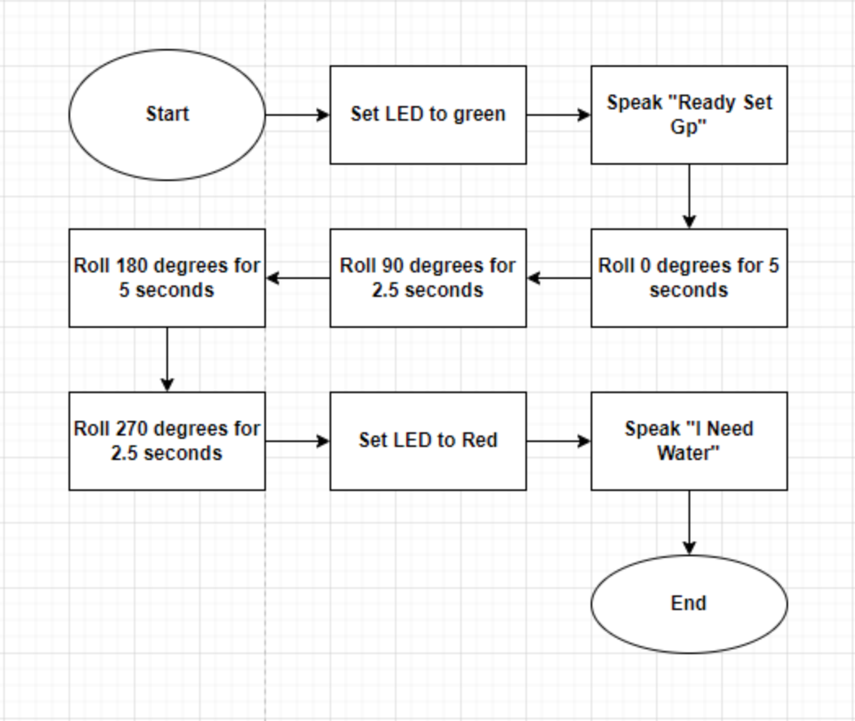

## ***Software***

* Sphero Edu program version 6.3.5
* macOS Big Sur Version 11.4 operating system

## ***Hardwar***e

* 2013 MacBook Pro (Late 2013)
* 2.4 GHz Dual-Core Intel Core i5 processor
* 8 GB 1600 MHz DDR3 memory

## ***Test Plan***

| **Reason for Test Case** | **Test Date** | **Expected Output** | **Observed Output** | **Staff Name** | **Pass/Fail** |
| --- | --- | --- | --- | --- | --- |
| Gauge approximate speed and distance needed to complete first vertical section of the course | 03/09/2022 | Robot will not be successful at traveling 1st measured distance | Robot went the wrong direction (improper aim) | DV | Fail |
| Continue to gauge approximate speed and distance needed to complete first vertical section of the course | 03/09/2022 | Robot will not be successful at traveling 1st measured distance | Robot was no successful at traveling 1st measured distance (to short of distance) | DV | Fail |
| Obtain correct distance of first leg of course | 03/09/2022 | Robot will travel correct distance of first leg and pivot | Robot traveled to short of distance | DV | Fail |
| Obtain correct distance of first vertical leg of course | 03/09/2022 | Robot will travel correct distance of first leg | Robot traveled correct distance of first leg | DV | Pass |
| Determine the correct speed and distance needed to successfully travel the 1st *horizontal* leg of the course | 03/09/2022 | Robot will travel correct distance of first leg, pivot 90 degrees, and unsuccessfully travel the length of the horizontal leg of the endurance sprint | Robot successfully traveled the correct distance of the first leg, pivoted 90 degrees and began traveling along the horizontal leg, but traveled the incorrect distance. | DV | Pass |
| Complete the first vertical and horizontal sections of the endurance course and successfully travel the second vertical section using the same speed and duration used during the first vertical section | 03/09/2022 | Robot will travel the correct distance of the first leg, pivot 90 degrees, successfully travel the length of the horizontal leg of the endurance sprint, then pivot 90 degrees to travel 180 degrees along the second vertical portion of the rectangular endurance course using the same speed and duration as the first vertical leg of the course | Robot was successful in all aspects but was obstructed by classroom furniture and pushed off axis | DV | Fail |
| Successfully travel 3 of 4 sides of the rectangular endurance course. | 03/09/2022 | Robot will travel the correct distance of the first leg, pivot 90 degrees, successfully travel the length of the horizontal leg of the endurance sprint, then pivot 90 degrees to travel 180 degrees along the second vertical portion of the rectangular endurance course using the same speed and duration as the first vertical leg of the course | Robot achieved the expected output | DV | Pass |
| Attempt to successfully travel the entire Endurance course | 03/09/2022 | Robot will travel the correct distance of the first leg, pivot 90 degrees, successfully travel the length of the horizontal leg of the endurance sprint, then pivot 90 degrees to travel 180 degrees along the second vertical portion of the rectangular endurance course using the same speed and duration as the first vertical leg of the course. Then finally pivot another 90 degrees to travel the last horizontal leg using the previously determined speed and distance from the first horizontal leg - thus returning to the starting point. | Robot achieved the expected output | DV | Pass |

## ***Task List/Gantt Chart***

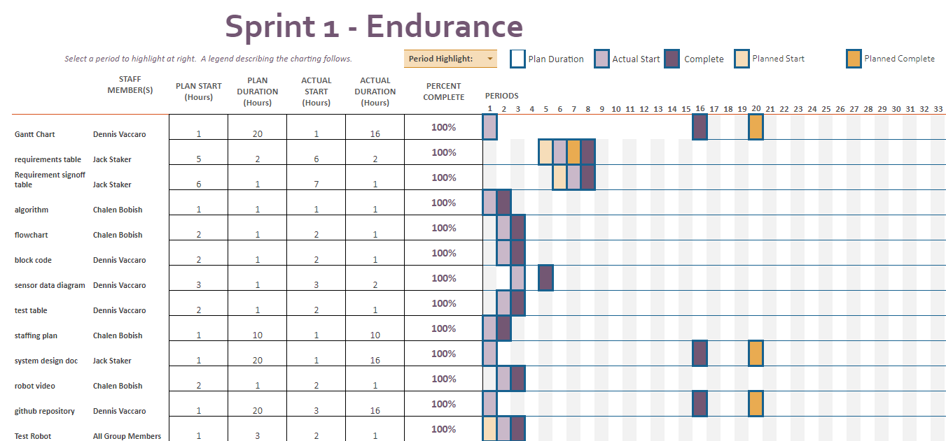

## ***Staffing Plan***

| Name | Role | Responsibility | Reports To |
| --- | --- | --- | --- |
| Chalen | Data/Planning | algorithm, flowchart, and robot testing | Jack |
| Dennis | Programmer | block code, test robot, Gantt chart, Sensor data diagram maintain Github | Jack |
| Jack | Manager | System design document, robot testing | N/A |